Class room activity:
RAG based multimodal test case Generator:
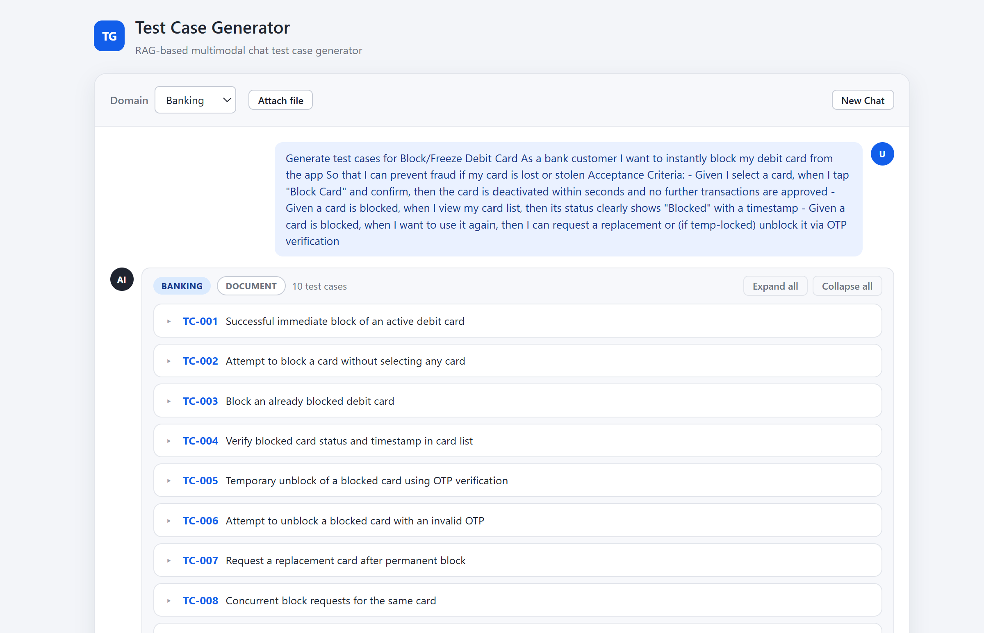
Added below vibe coding for further enhancements:
Analyze the entire code and implement the changes for the following

1. add another domain as Retail
2. include chat memory options
3. generate positive and negative test cases
3. Replace the plain text list of generated testcases with a structured table.
Columns: TestCaseID, TestCaseName, Description, Steps, Expected results, Priority
4.Add Color to the UI
Give the generator a personality.
Color semantics:
Green → Positive test cases
Red → Negative test cases
Blue → Informational or optional flows

UI vibe:
Soft gradients
Smooth transitions when new test cases appear
Domain dropdown styled with subtle accents (Retail → Orange, Banking → Blue, Insurance-grey, hospital - pink)
Give me step by step implementation and proceed after approval

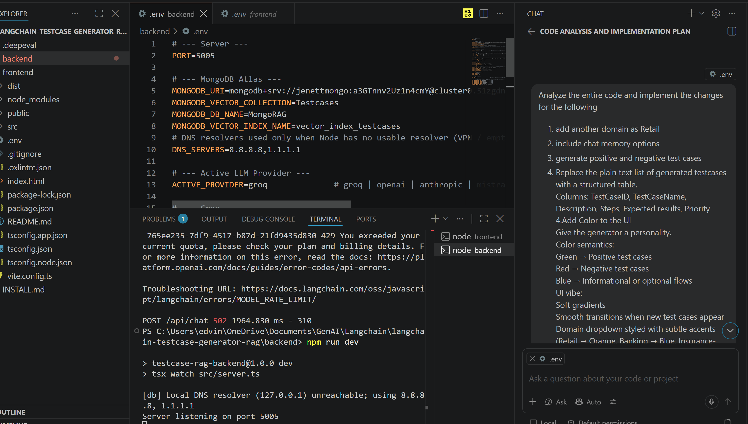

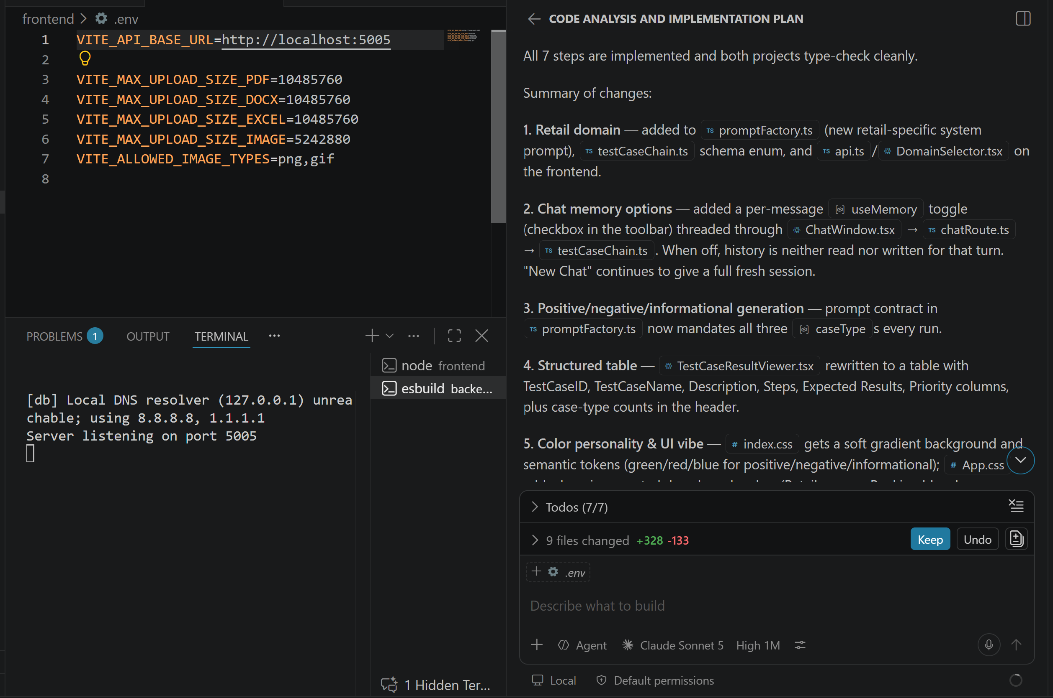

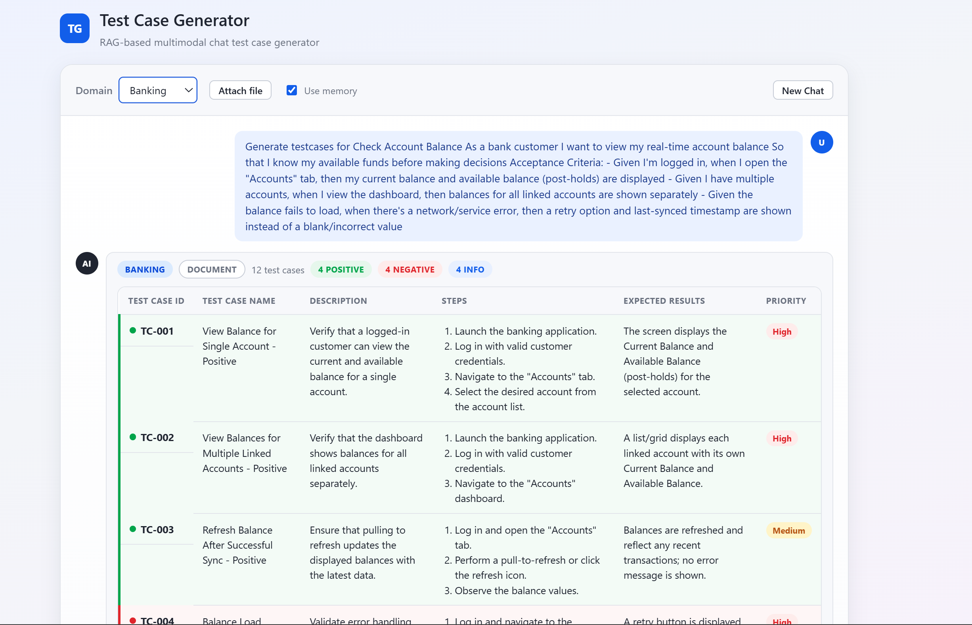

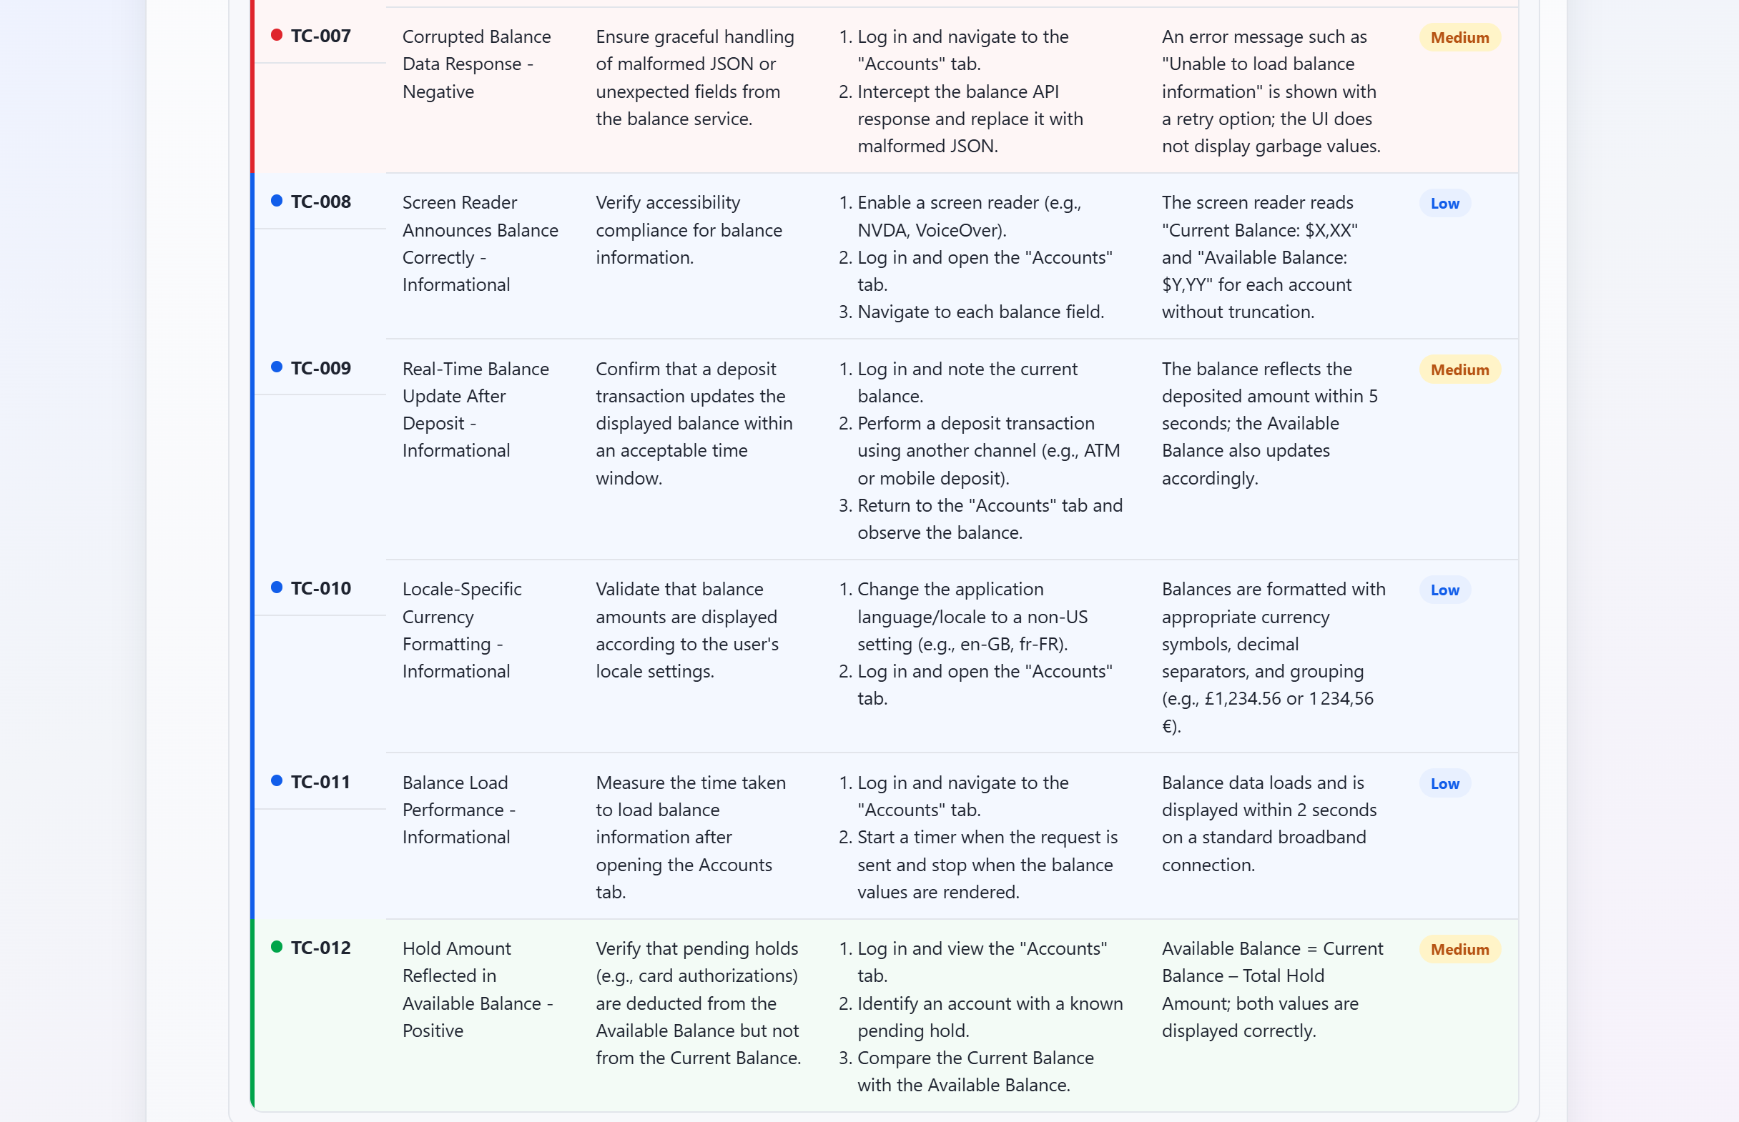

Added a feature to export generated testcases in csv or an excel format.

